AMAZON WEB SERVICES
Amazon Simple Notification Service
(SNS)

Service | Amazon Simple Notification Service (SNS)
Region | Asia Pacific (Mumbai) - ap-south-1
Topic type | Standard
Protocol used | Email

1. Introduction
Amazon Simple Notification Service (Amazon SNS) is a fully managed publish/subscribe messaging service from AWS. It lets an application, a person or another AWS service send a message once and have it delivered automatically to many receivers at the same time. The sender is called the publisher, the channel that carries the message is called a topic, and every receiver that listens to the topic is called a subscriber. Because the publisher never needs to know who the subscribers are, the parts of a system are loosely coupled and can grow or change independently. SNS is highly available, durable and secure, and it is commonly used for alerts, order notifications, application-to-application messaging, mobile push notifications, SMS messages and email updates. It supports Standard topics, which give maximum throughput, and FIFO topics, which keep strict ordering. Subscribers can be Amazon SQS queues, AWS Lambda functions, HTTP or HTTPS endpoints, Amazon Data Firehose, mobile applications, SMS numbers and email addresses. There are no upfront costs; you pay only for the messages you publish and deliver.
What you will do in this guide
- Open the Amazon SNS console and create a Standard topic.
- Review the encryption, access policy, delivery policy, tag and tracing options.
- Create an email subscription and confirm it from the inbox.
- Publish a test message to the topic and receive it by email.
- Unsubscribe the email address and verify that the subscription is deleted.
Prerequisites
- An active AWS account with permission to use Amazon SNS.
- Access to the AWS Management Console in a web browser.
- An email address whose inbox you can open to confirm the subscription.

1 | STEP 1  Open the Amazon SNS Console and Enter the Topic Name
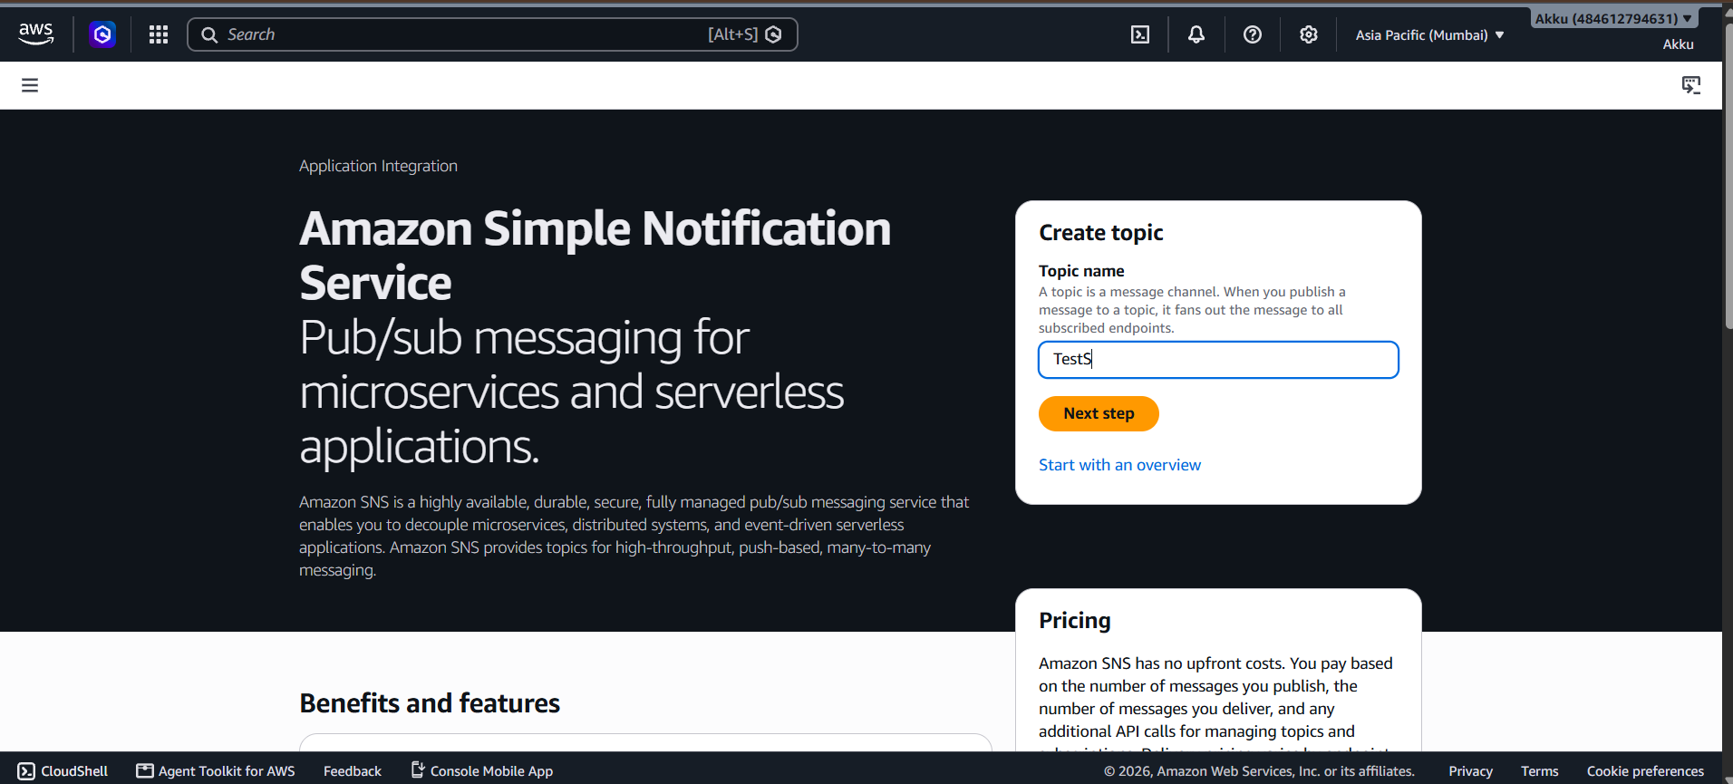
Figure 1: Amazon SNS landing page with the Create topic card
Sign in to the AWS Management Console and confirm that the correct Region is selected in the top-right corner of the page. In this guide the Asia Pacific (Mumbai) Region, ap-south-1, is used, because an SNS topic exists only in the Region where it is created. Type "SNS" into the search bar at the top (or press Alt+S) and choose Simple Notification Service from the list of results. The service landing page opens with the heading "Pub/sub messaging for microservices and serverless applications" and a short description of what the service does. On the right side you will see a Create topic card. A topic is a message channel: when you publish a message to a topic, SNS fans the message out to every endpoint that is subscribed to it. Type the name you want to give your topic into the Topic name box, and then click the orange Next step button to move on to the full topic configuration page.
Key points
- A topic name can contain alphanumeric characters, hyphens and underscores, up to 256 characters.
- The Pricing card on the same page explains that SNS has no upfront cost; you pay for what you publish and deliver.
- Choose Start with an overview if you prefer a guided introduction to the service first.
- Always double-check the Region before creating resources, so that they are easy to find later.

2 | STEP 2  Choose the Topic Type and Basic Details
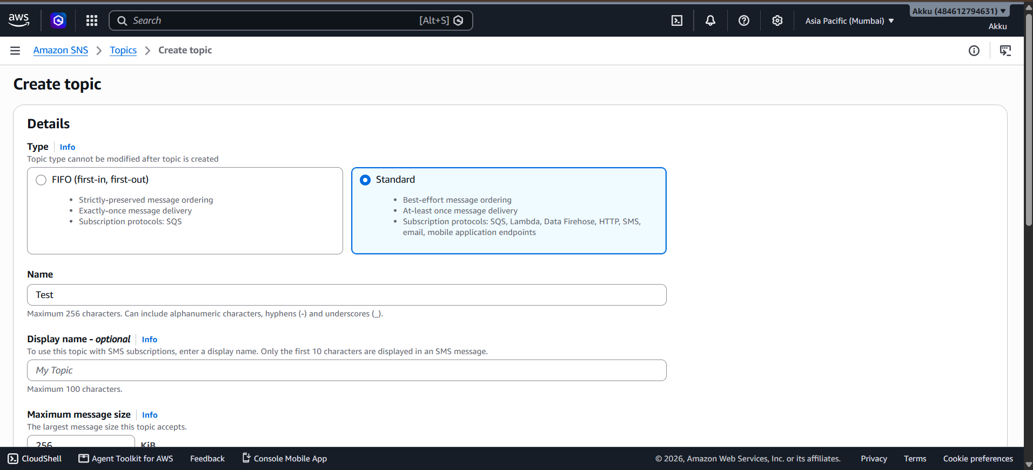
Figure 2: Create topic page - Type, Name and Display name
After clicking Next step, the Create topic page opens with the Details section at the top. The first choice is the topic Type, and this choice cannot be changed once the topic has been created. FIFO (first-in, first-out) topics preserve strict message ordering and provide exactly-once delivery, but they can only deliver to Amazon SQS queues. Standard topics offer best-effort ordering and at-least-once delivery, and they support many subscription protocols such as SQS, Lambda, Data Firehose, HTTP, SMS, email and mobile application endpoints. Because we want to send a notification to an email address, the Standard option is selected here. Next, enter the topic name in the Name field; in this example the name is Test. The Display name field is optional and is only needed if the topic will be used with SMS subscriptions, where the first ten characters are shown in the text message. Finally, the Maximum message size field shows the largest message this topic accepts.
Key points
- Standard type is required for the Email protocol used later in this guide.
- The topic name is permanent; to use a different name you must create a new topic.
- Leave Display name empty unless you plan to use SMS delivery.
- The default maximum message size is 256 KiB and can be set between 1 KiB and 1024 KiB.

3 | STEP 3  Review the Encryption and Access Policy Settings
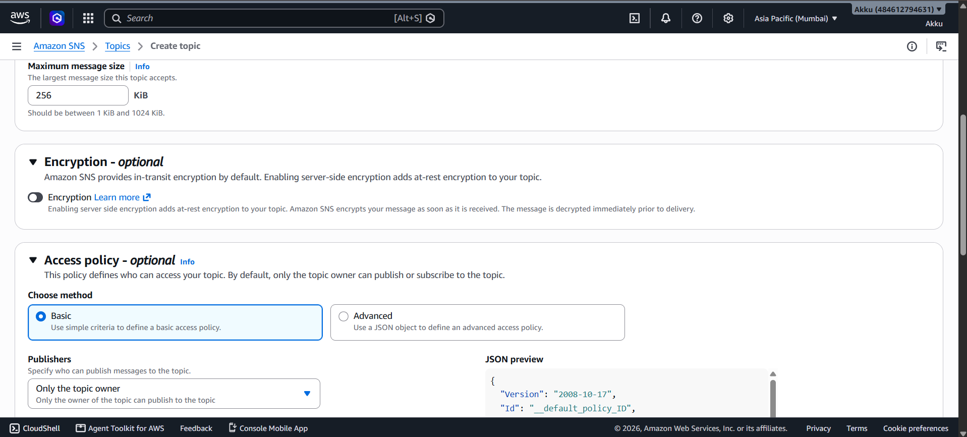
Figure 3: Maximum message size, Encryption and Access policy sections
Scroll down the Create topic page to review the optional configuration sections. Under Maximum message size, the default value of 256 KiB is kept, and the console reminds you that the value must be between 1 KiB and 1024 KiB. The Encryption section explains that Amazon SNS already provides in-transit encryption by default, and that enabling server-side encryption adds encryption at rest: SNS encrypts a message as soon as it is received and decrypts it immediately before delivery. For this simple demonstration the Encryption toggle is left switched off, but for production workloads that carry sensitive data it is a good practice to turn it on. The Access policy section defines who is allowed to publish to and subscribe to the topic. The Basic method is selected, and under Publishers the option Only the topic owner is chosen, which means that only the AWS account that owns the topic can publish messages to it. A JSON preview on the right side shows the policy that will be generated.
Key points
- Encryption at rest is optional and is controlled by a single toggle.
- Choose the Advanced access-policy method if you need to write a custom JSON policy.
- Restricting publishers to the topic owner is the safest default for a test topic.
- The JSON preview updates automatically whenever you change the policy options.

4 | STEP 4  Review the Delivery Policy (HTTP/S)
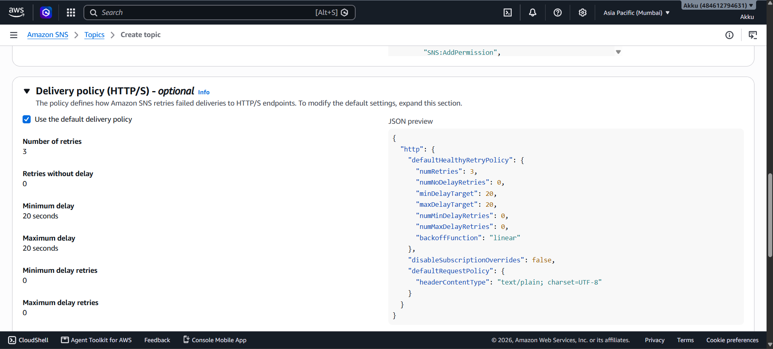
Figure 4: Delivery policy (HTTP/S) with the default retry settings
Continue scrolling to the Delivery policy (HTTP/S) section, which defines how Amazon SNS retries failed deliveries to HTTP or HTTPS endpoints. The checkbox Use the default delivery policy is ticked, so SNS applies its standard retry behaviour. The values shown on the left are the number of retries (3), retries without delay (0), minimum delay (20 seconds), maximum delay (20 seconds), minimum delay retries (0) and maximum delay retries (0). The JSON preview on the right shows the same settings in policy form, including the defaultHealthyRetryPolicy block, the backoff function set to linear, and the default request policy with the content type text/plain. Since our subscription will use the Email protocol and not HTTP or HTTPS, none of these values affect our test, and it is safe to leave the default policy selected. If you later subscribe a web application, you can untick the checkbox here to customise the retry count and delay times.
Key points
- The delivery policy applies only to HTTP/S subscriptions, not to email.
- The default policy retries a failed delivery three times with a 20 second delay.
- Untick the checkbox to edit the retry and back-off values.
- Keeping the defaults is recommended when you are only testing.

5 | STEP 5  Skip Tags and Active Tracing, then Create the Topic
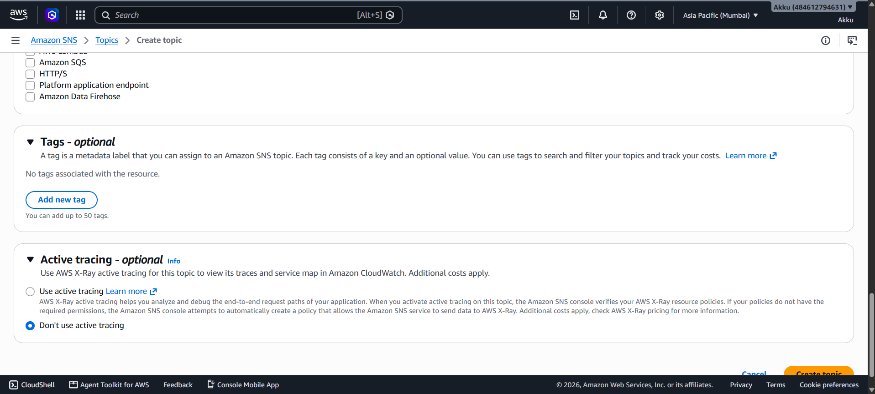
Figure 5: Tags, Active tracing and the Create topic button
At the bottom of the page you will find the remaining optional sections. At the top of the screenshot you can see a list of check boxes for AWS Lambda, Amazon SQS, HTTP/S, Platform application endpoint and Amazon Data Firehose; these belong to the optional delivery status logging settings and none of them needs to be ticked for this example. The Tags section lets you attach metadata labels, each made of a key and an optional value, to the topic so that you can search, filter and track its cost; up to 50 tags can be added, and this guide adds none. The Active tracing section lets you use AWS X-Ray to view traces and a service map for the topic in Amazon CloudWatch, but additional costs apply, so the option Don't use active tracing is kept selected. After checking every section once more, scroll to the very bottom of the page and click the orange Create topic button. Clicking Cancel instead would discard everything you have entered so far.
Key points
- Tags are optional but very useful for cost allocation in larger accounts.
- Active tracing with AWS X-Ray adds extra cost, so keep it off for a test topic.
- No delivery-status or encryption changes are needed for this walkthrough.
- Click Create topic once; the console will then open the new topic automatically.

6 | STEP 6  Verify That the Topic Was Created Successfully
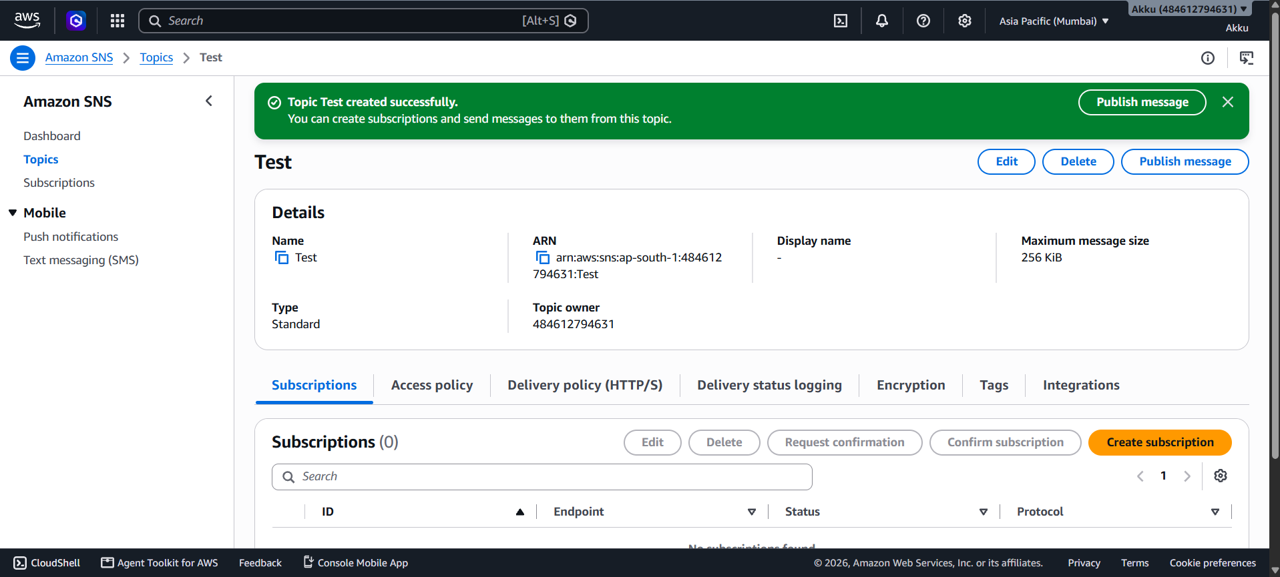
Figure 6: Topic created successfully - topic details page
As soon as the topic is created, the console opens the topic details page and displays a green banner saying that the topic was created successfully and that you can now create subscriptions and send messages to it. The Details panel summarises the new topic. It shows the Name (Test), the ARN, the Display name (empty), the Maximum message size (256 KiB), the Type (Standard) and the Topic owner, which is your 12-digit AWS account number. The ARN, or Amazon Resource Name, uniquely identifies the topic and has the form arn:aws:sns, followed by the Region, the account number and the topic name; you will need it whenever you publish or subscribe from the CLI or an SDK. Below the details there is a row of tabs: Subscriptions, Access policy, Delivery policy (HTTP/S), Delivery status logging, Encryption, Tags and Integrations. The Subscriptions tab currently shows zero subscriptions, because nobody has subscribed to the topic yet. The buttons Edit, Delete and Publish message appear at the top right.
Key points
- Copy the topic ARN; it is required in the next step.
- Subscriptions (0) confirms that the topic exists but has no receivers yet.
- Use the Edit button to change optional settings of the topic later.
- Use the Delete button only when the topic is no longer needed.

7 | STEP 7  Create a Subscription with the Email Protocol
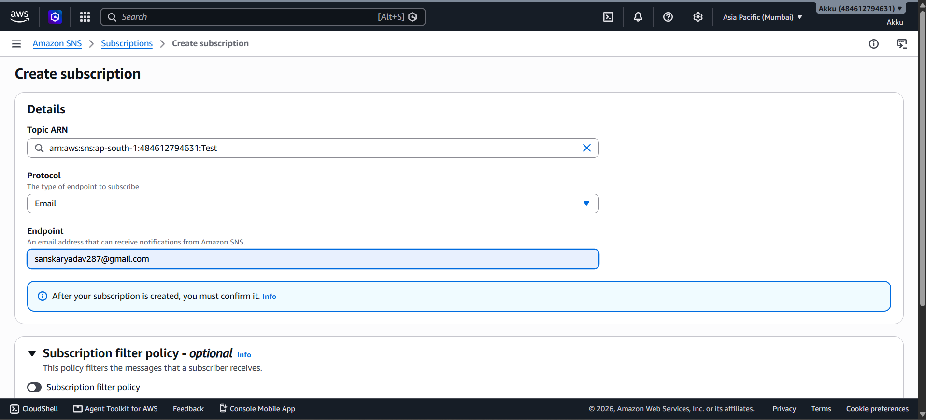
Figure 7: Create subscription page with the Email protocol and endpoint
To receive the messages that are published to the topic, you must subscribe an endpoint to it. On the topic details page, click the orange Create subscription button in the Subscriptions panel. The Create subscription page opens, and the Topic ARN field is already filled with the ARN of the topic that you just created. In the Protocol drop-down list, choose Email, which sends every message to an email inbox. The Endpoint field then asks for an email address that can receive notifications from Amazon SNS, so type the address of the inbox you want to use, taking care to avoid typing mistakes. A blue information box reminds you that after your subscription is created, you must confirm it. The optional Subscription filter policy section below can be used to deliver only selected messages to this subscriber, but it is left switched off here. Scroll down and click Create subscription to finish.
Key points
- The endpoint must be an inbox you can open, because a confirmation email is sent to it.
- Other available protocols include Amazon SQS, AWS Lambda, HTTP/S, SMS and Email-JSON.
- A filter policy is optional and can be added or changed later.
- The subscription does not become active until the recipient confirms it.

8 | STEP 8  Check the Subscription Status: Pending Confirmation
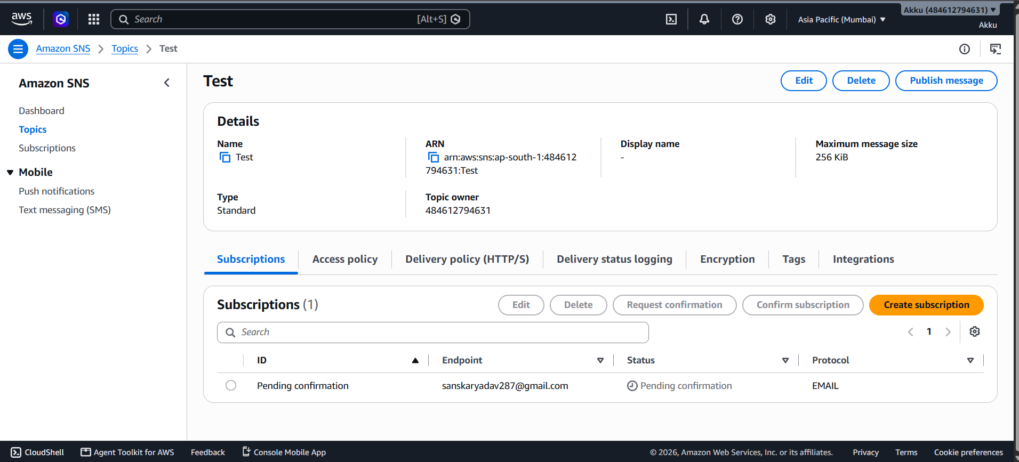
Figure 8: Subscriptions (1) shown with the status Pending confirmation
After the subscription is created, the console returns to the topic details page, and the Subscriptions panel now shows Subscriptions (1). The new row lists the ID, the Endpoint (the email address that you entered), the Status and the Protocol (EMAIL). The ID and the Status both show Pending confirmation, which means that Amazon SNS has sent a confirmation message to the email address and is waiting for the owner of that inbox to approve the subscription. Until this approval is given, no notifications will be delivered to the address, which is an important safeguard that prevents anyone from signing you up for messages without your consent. If the confirmation email does not arrive within a few minutes, check the spam or promotions folder, or select the subscription and use the Request confirmation button to send the message again. The Confirm subscription button is used when you already have the confirmation token.
Key points
- Pending confirmation is the normal first state of every email subscription.
- Use Request confirmation to resend the email if it does not arrive.
- No messages are delivered while the status is pending.
- Refresh the page after confirming to see the updated status.

9 | STEP 9  Open the AWS Notification Email
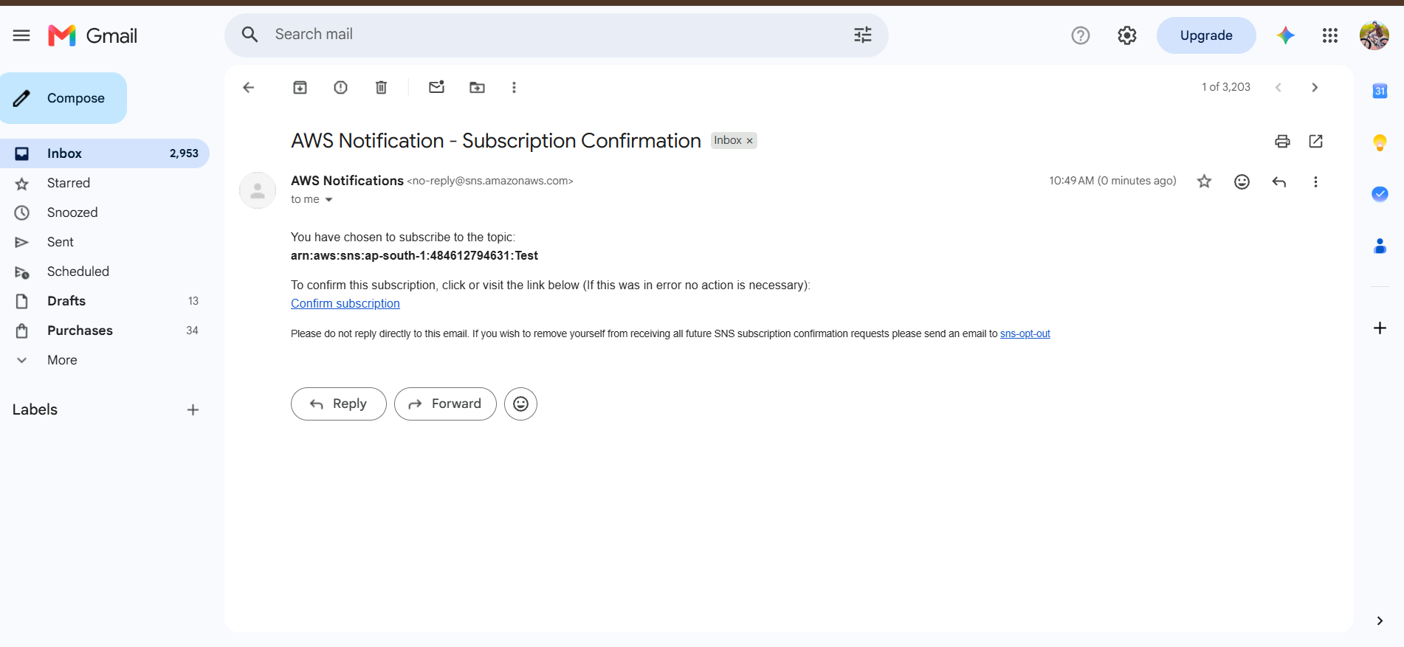
Figure 9: Gmail inbox showing the AWS Notification - Subscription Confirmation email
Open the inbox of the email address that was used as the endpoint. A new message with the subject AWS Notification - Subscription Confirmation has arrived from AWS Notifications, sent from the address no-reply@sns.amazonaws.com. The body of the email says that you have chosen to subscribe to the topic and prints the full topic ARN, so that you can verify that it is the topic you expect. Below it, the email explains that to confirm the subscription you should click or visit the link named Confirm subscription, and that if the message was received in error, no action is necessary and the subscription will simply stay unconfirmed. At the bottom, a small note explains that you should not reply directly to this email, and that you can send a message to the sns-opt-out address if you want to stop receiving all future SNS subscription confirmation requests. Click the Confirm subscription link to approve the subscription.
Key points
- The sender is no-reply@sns.amazonaws.com, so replying to the email has no effect.
- Check the topic ARN in the message before confirming.
- Ignore the email if you did not request the subscription.
- If the email is missing from the inbox, look in the spam folder.

10 | STEP 10  Confirm the Subscription
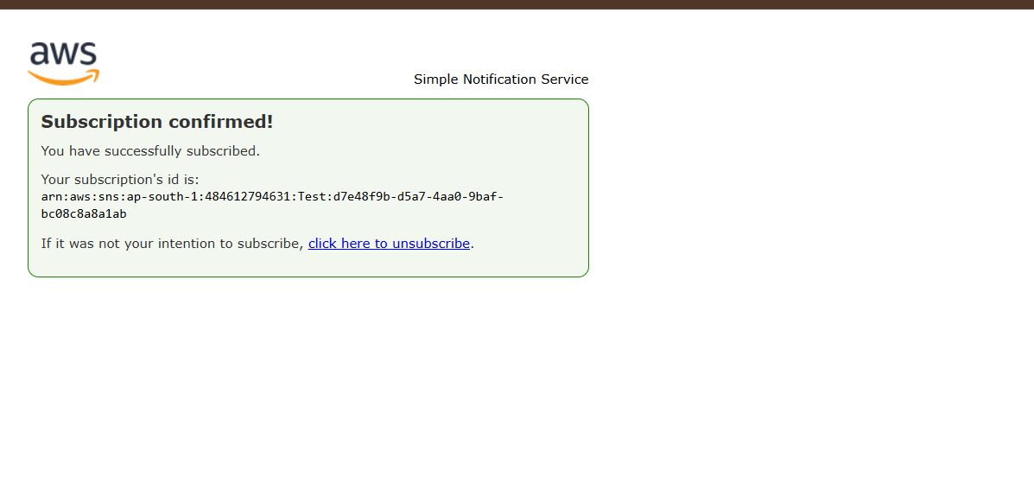
Figure 10: Subscription confirmed! page of Amazon Simple Notification Service
Clicking the Confirm subscription link opens a new browser tab that belongs to the Simple Notification Service. The page shows a green box with the heading Subscription confirmed! and the text You have successfully subscribed. It also prints your subscription's ID, which is the topic ARN followed by a unique identifier, and this value is what identifies this particular subscription from now on. At the bottom of the box there is a link, click here to unsubscribe, that can be used at any time if it was not your intention to subscribe. From this moment on, the email address is an active subscriber of the topic, and every message that is published to the topic will be forwarded to its inbox. You can now close this tab and return to the AWS console, where the status of the subscription can be checked. Note that the confirmation link works only once for a given request and should not be shared with other people.
Key points
- A green box with Subscription confirmed! means the process worked.
- The subscription ID is unique to this topic and email address.
- The unsubscribe link in this page can be used to cancel the subscription.
- Close the tab and refresh the SNS console to see the new status.

11 | STEP 11  Verify the Status Changed to Confirmed
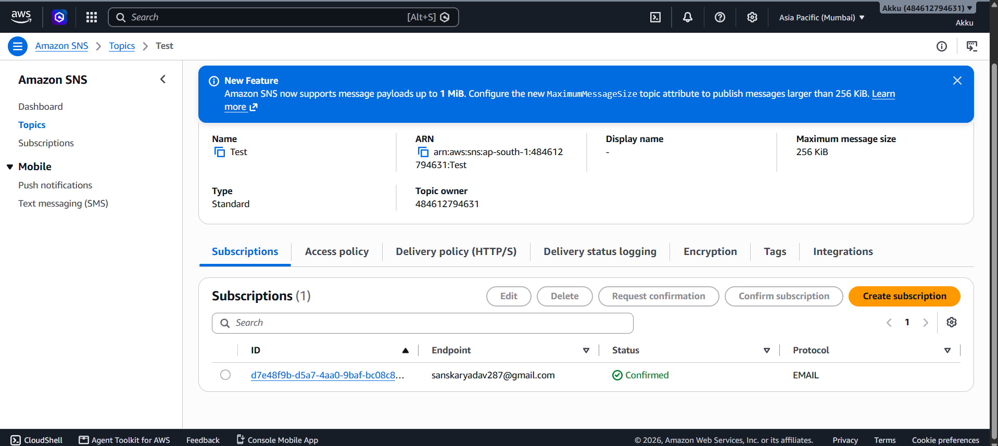
Figure 11: Subscription status changed to Confirmed in the SNS console
Go back to the Amazon SNS console, open the Topics page and click the topic name again (or simply refresh the page). The Subscriptions panel now shows the subscription with a proper ID, a long identifier that starts with d7e48f9b and is displayed as a blue link, instead of the earlier text Pending confirmation. The Status column now contains a green check mark with the word Confirmed, the Endpoint column shows the email address and the Protocol column shows EMAIL. This is the proof that the subscription is active and ready to receive messages. A blue New Feature banner at the top of the page announces that Amazon SNS now supports message payloads up to 1 MiB, which can be enabled through the MaximumMessageSize topic attribute; this banner is informational and can be closed with the X button. Clicking the ID link opens a detail page where you can view the subscription attributes, such as the endpoint, the owner and the filter policy.
Key points
- Confirmed is the final, healthy status for an email subscription.
- The ID turns into a clickable link once the subscription is confirmed.
- The blue New Feature banner is only informational.
- Use the Search box to find a subscription when the list becomes long.

12 | STEP 12  Start Publishing a Message: Subject and Options
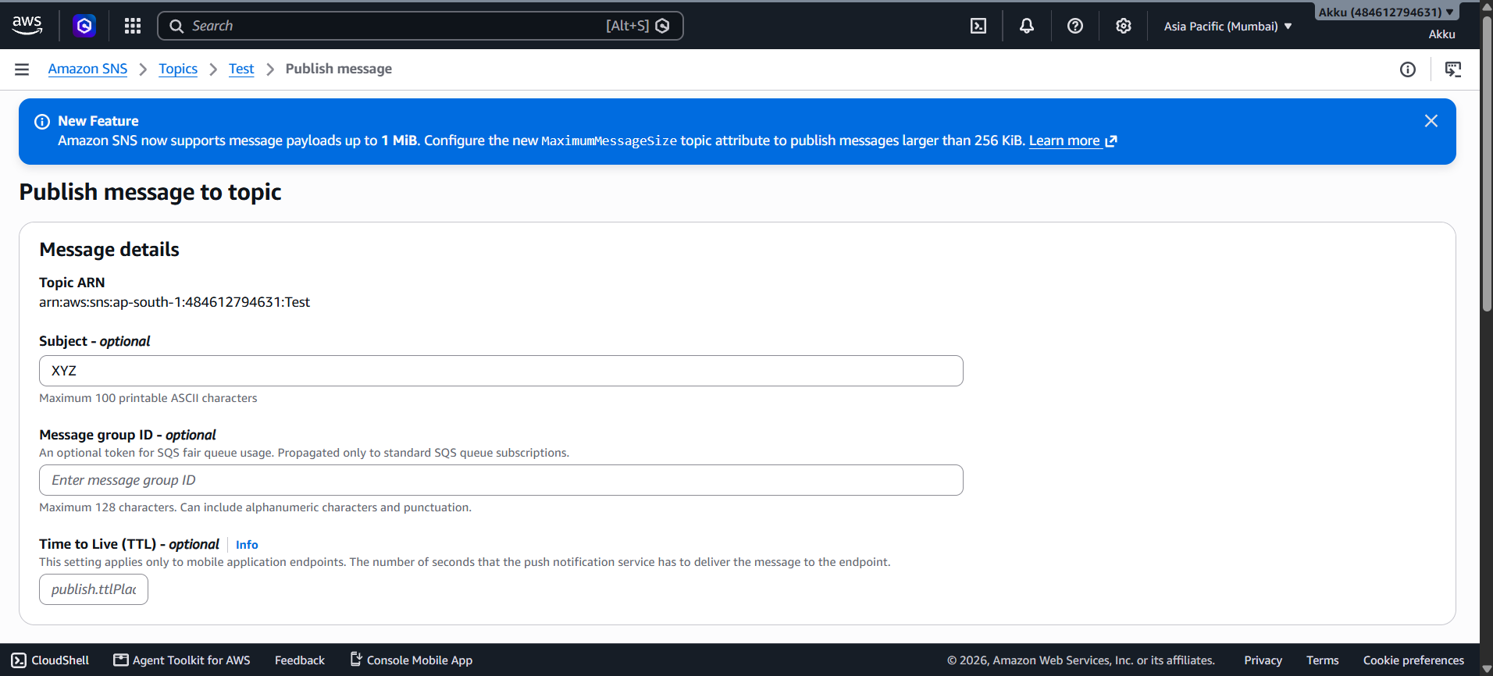
Figure 12: Publish message to topic - Message details and Subject
With a confirmed subscriber in place, the topic can now be tested by publishing a message. On the topic details page click the Publish message button at the top right. The Publish message to topic page opens, and the Message details section starts with the Topic ARN, shown as plain text so that you can verify that you are publishing to the correct topic. The Subject field is optional; it accepts a maximum of 100 printable ASCII characters and, for email subscribers, it becomes the subject line of the email, so XYZ is typed here as an example. The Message group ID field is optional and is only used with SQS fair queues; it is propagated only to standard SQS queue subscriptions and is left empty. The Time to Live (TTL) field applies only to mobile application endpoints and defines how many seconds the push notification service has to deliver the message, so it is also left empty for an email test.
Key points
- The Subject becomes the email subject for email subscribers.
- Subject is limited to 100 printable ASCII characters.
- Message group ID and TTL can be ignored for a simple email test.
- Always confirm the Topic ARN shown at the top before publishing.

13 | STEP 13  Write the Message Body and Publish It
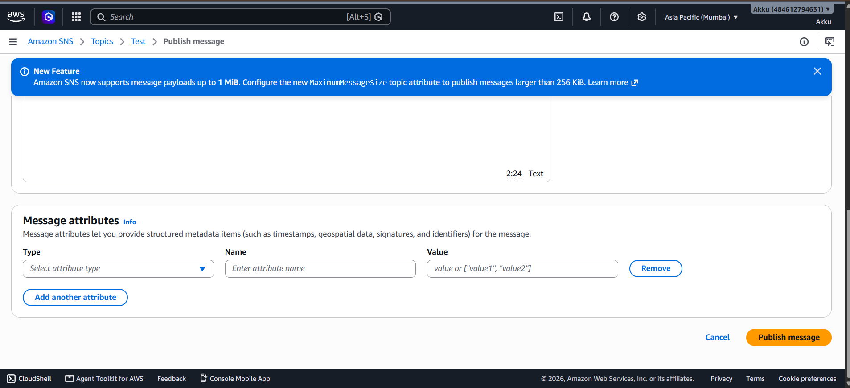
Figure 13: Message body, Message attributes and the Publish message button
Scroll down the same page to the Message body section, where the text of the notification is typed into the large editor. For this test the body is a short note that reads Hello, I am Sanskar from AWS, followed by a second line asking whether the recipient can purchase the AWS services. The editor is set to the Text format, as shown at the bottom right of the box, and it also displays the cursor position. Below the body you will find the Message attributes section, which lets you add structured metadata, such as timestamps, geospatial data, signatures and identifiers, to the message. Each attribute needs a Type, a Name and a Value. Attributes are optional, so the row is left empty for this demonstration. When everything looks correct, click the orange Publish message button at the bottom right of the page. The Cancel link next to it returns to the topic without sending anything.
Key points
- The message body is the actual content that subscribers receive.
- Message attributes are optional and are mainly used for filtering.
- Click Publish message only once to avoid sending duplicates.
- A green success banner confirms that SNS accepted the message.

14 | STEP 14  Receive the Published Message in the Email Inbox
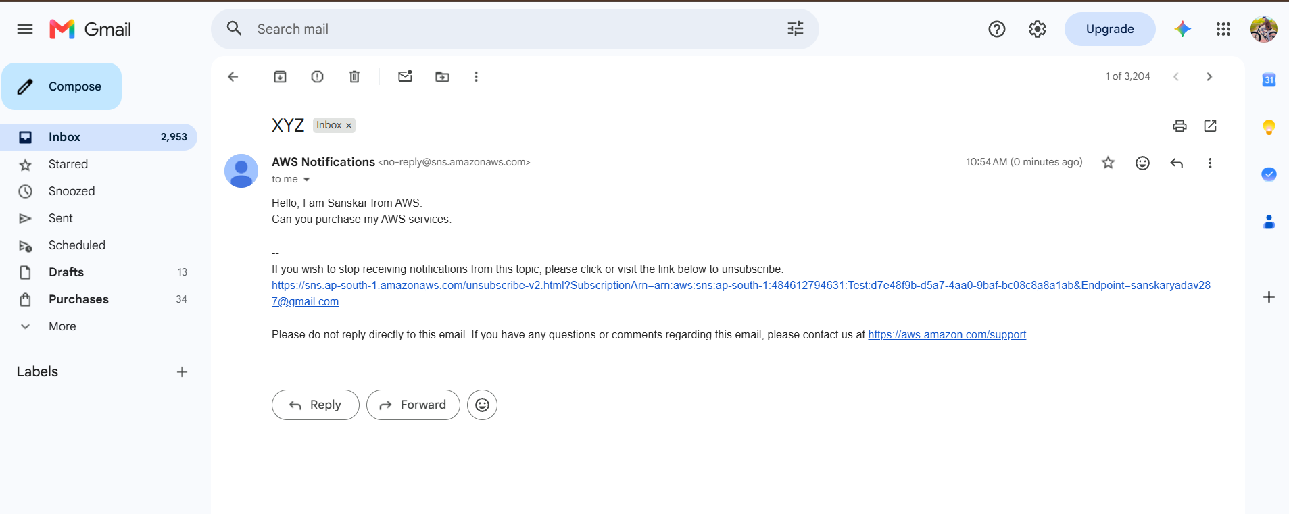
Figure 14: The published message delivered to the subscriber's Gmail inbox
Within a few seconds of publishing, the message arrives in the inbox of the subscribed email address. The email has the subject XYZ, exactly as it was typed in the Subject field, and it is sent from AWS Notifications at no-reply@sns.amazonaws.com. The body contains the text written in the Message body box, the greeting from Sanskar and the question about purchasing AWS services, so the content is identical to what was published. Amazon SNS automatically appends a footer that explains how to stop receiving notifications from the topic, together with a long unsubscribe link that contains the subscription ARN and the endpoint address. A second line tells the reader not to reply directly to the email and points to the AWS support page for questions or comments. This delivery proves that the full workflow works from end to end: a topic was created, an email address was subscribed and confirmed, and a published message was fanned out to the subscriber.
Key points
- The email subject equals the Subject entered while publishing.
- The unsubscribe link is added automatically to every email notification.
- Delivery normally takes only a few seconds.
- Receiving this email confirms that the whole setup is working correctly.

15 | STEP 15  Unsubscribe the Email Address
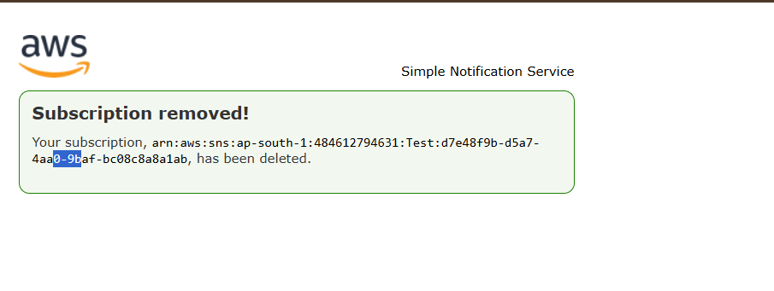
Figure 15: Subscription removed! confirmation page
A subscriber can leave a topic at any time, without any help from the topic owner. To do this, click the unsubscribe link that is printed at the bottom of the notification email. A new browser tab opens on the Simple Notification Service and shows a green box with the heading Subscription removed!. The box prints the full subscription ARN, which consists of the topic ARN and the unique subscription identifier, and states that this subscription has been deleted. From now on, the address will no longer receive any message that is published to the topic, and no further confirmation is required. If the unsubscribe was a mistake, the owner of the topic has to create a new subscription for the same address, and the recipient has to confirm it again with a new confirmation email. Alternatively, the topic owner can remove a subscriber directly from the console by selecting the subscription and clicking Delete in the Subscriptions panel.
Key points
- Unsubscribing takes effect immediately.
- The page shows the exact subscription ARN that was removed.
- A removed subscriber must be re-subscribed and re-confirmed to receive messages again.
- The topic owner can also delete subscriptions from the console.

16 | STEP 16  Verify the Subscription Has Been Deleted
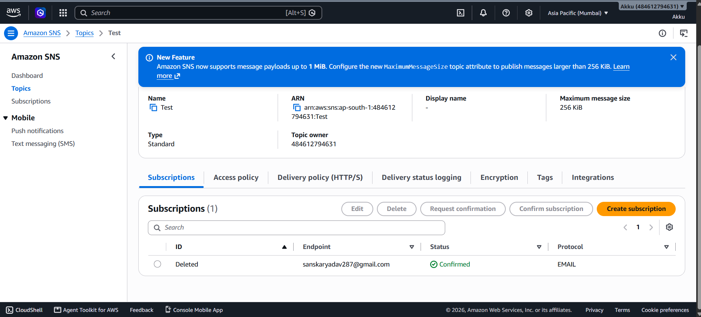
Figure 16: Subscription ID shows Deleted after unsubscribing
Return to the Amazon SNS console and open the Test topic once more to verify the result of the unsubscribe action. In the Subscriptions panel, the ID column of the row now displays the word Deleted instead of the long identifier link, which shows that Amazon SNS has removed the subscription and that it is no longer linked to a valid subscription ARN. The endpoint still shows the email address and the Status column may continue to show Confirmed for a short time, because the list is cached until it is refreshed or until SNS clears the removed entry. Refreshing the page after a minute or two removes the stale row, and the panel returns to Subscriptions (0). At this point the complete life cycle has been demonstrated: topic creation, subscription, confirmation, publishing, delivery and unsubscription. If you no longer need the Test topic, you can click Delete at the top of the page to remove it and avoid any unwanted charges.
Key points
- The word Deleted in the ID column confirms that the subscription was removed.
- Refresh the page to clear the stale row from the list.
- Delete the topic when you finish testing to keep the account tidy.
- Review the topic's Subscriptions tab regularly to remove unused endpoints.

2. Conclusion
In this guide an Amazon SNS topic was created from the AWS console, an email address was subscribed to it, the subscription was confirmed through the link in the confirmation email, and a test message was published and delivered to the inbox. Finally, the subscriber was removed with the unsubscribe link and the deletion was verified in the console. These steps show the complete life cycle of a basic SNS notification workflow and the safeguards that AWS builds into it, such as the mandatory subscription confirmation and the automatic unsubscribe link in every email. The same pattern can be reused for real projects: replace the email endpoint with an SQS queue or a Lambda function, add a subscription filter policy to deliver only selected messages, turn on server-side encryption for sensitive data, and use tags to track the cost of each topic.
Best practices to remember
- Choose the topic type carefully, because it cannot be changed after creation.
- Keep the access policy restricted to the topic owner unless other accounts need access.
- Enable encryption for topics that carry sensitive information.
- Delete test topics and unused subscriptions to keep the account clean and avoid charges.

